Problem Statement 1:

Use the given dataset Quarterly_Estimates_of_GDP.xlsx and load it into a tableau workbook.

The following are the tasks that are to be taken into consideration while constructing graphs and charts in the worksheets.

Dataset Description:

This data is given by RBI’s official website and the data set contains the data of Indian GDP from various decades. We will do all operations on the last decade 2011-21 so select that table only and read the below detail carefully.

1. In the dataset,many sectors are given and they represent their contribution toward GDP.
2. Q1, Q2, Q3 & Q4 denote - April to June, July to September, October to December, and January to March quarters, respectively.
3. All values are in (Rupees Crore).
4. “Total Gross Value Added” is the final sum of all sectors.

1.Load the given dataset into a tableau workbook.

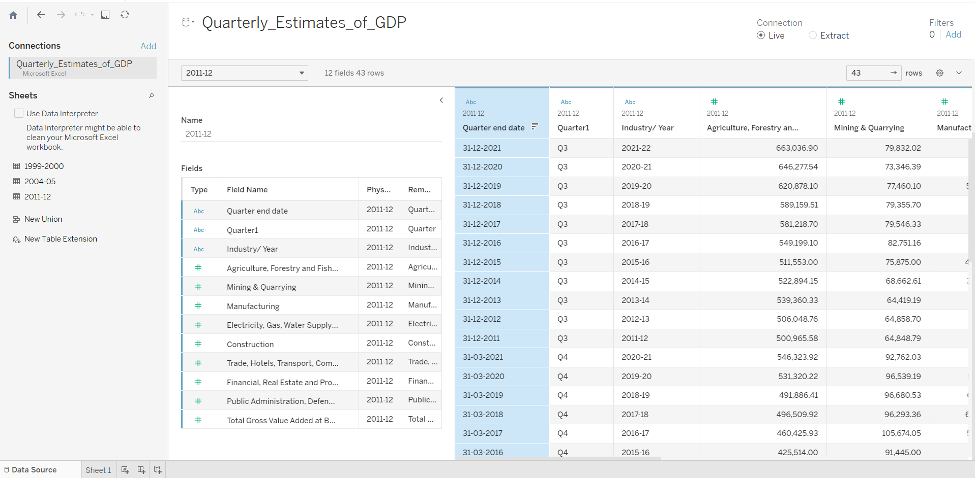

2. Change the “quarter-end date” column’s data type to date.

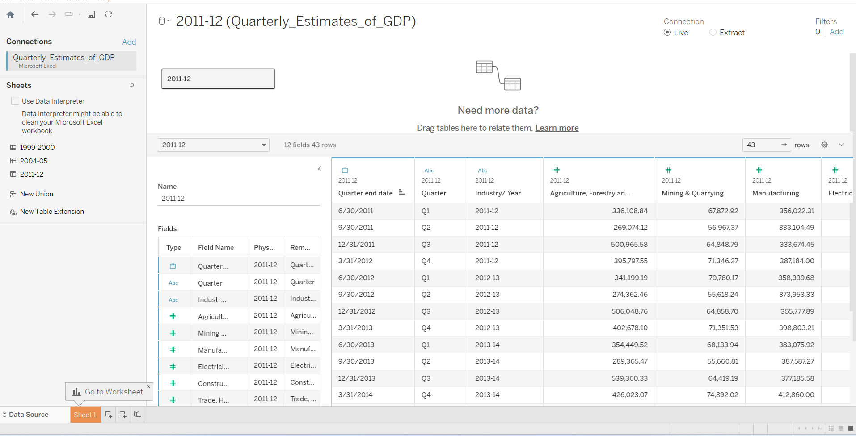

3.Print line for an entire given timeline for “Total Gross Value Added”

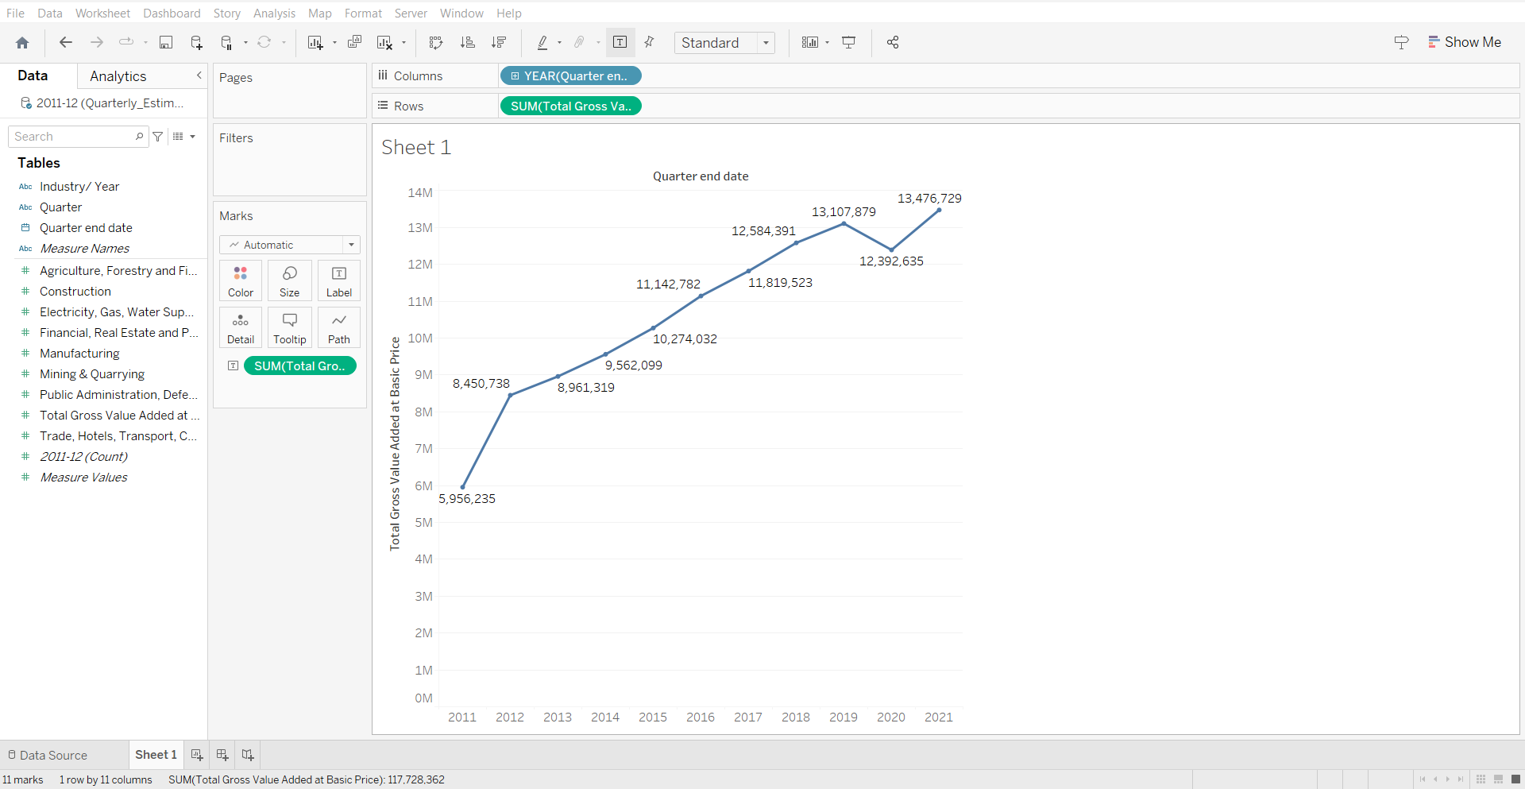

4.Open a new sheet and find out the total contribution of Agriculture, Forestry, and Fishing fields to GDP for each year and each quarter with the help of a bar plot (use different color pellets to represent each quarter.)

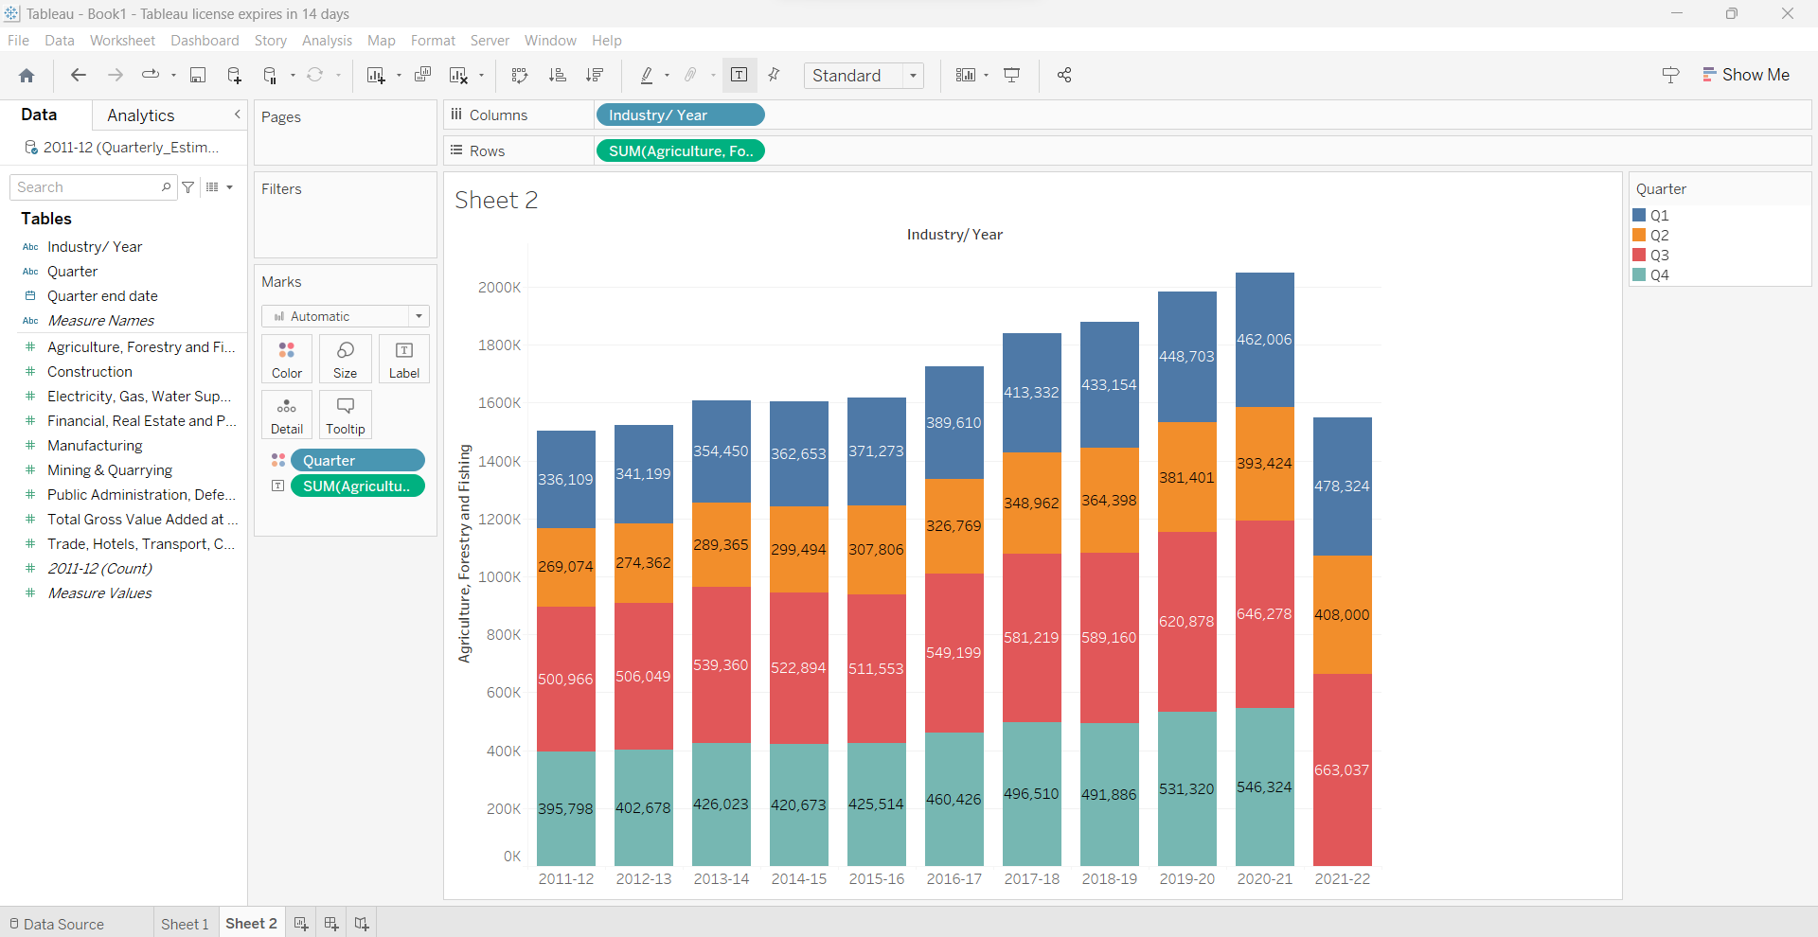

5. Compare the contribution of manufacturing, mining, quarrying, and financial and real estate sectors and their contribution to GDP each year quarter-wise with the help of a bar plot.

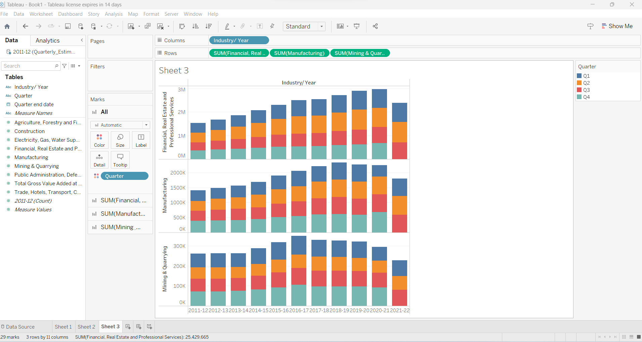

6.Find out in which quarter the agriculture and fishing sector contributed more to GDP in all years with help of a pie chart and try to conclude why.

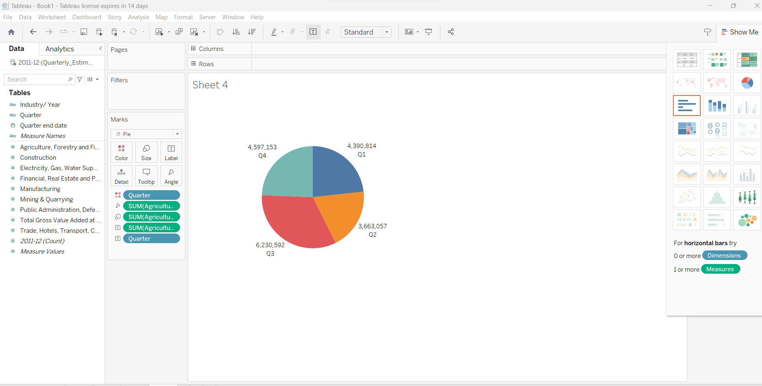

**Problem Statement 2 :**

Use the given dataset Quarterly_Estimates_of_GDP.xlsx and load it into a tableau workbook.

The following are the tasks that are to be taken into consideration while constructing graphs and charts in the worksheets.

**Dataset Description:**

This data is given by RBI’s official website and the data set contains the data of Indian GDP from various decades,we will do all operations on the last decade 2011-21 so select that table only and read the below detail carefully.

1.In the dataset,many sectors are given and they represent their contribution towardGDP.

2.Q1, Q2, Q3 & Q4 denote-April to June, July to September, October to December, andJanuary to March quarters, respectively.

3.All values are in (Rupees Crore).

4.“Total Gross ValueAdded” is the final sum of all sectors

1.Load the given dataset into a tableau workbook.



2.Change the “quarter-end date” column’s data type to date.



3.Make a hierarchy of “year”, “quarter”, and “quarter-end date” in the given order, and using a bar plot, observe “Public Administration, Defence, and Other Services”.

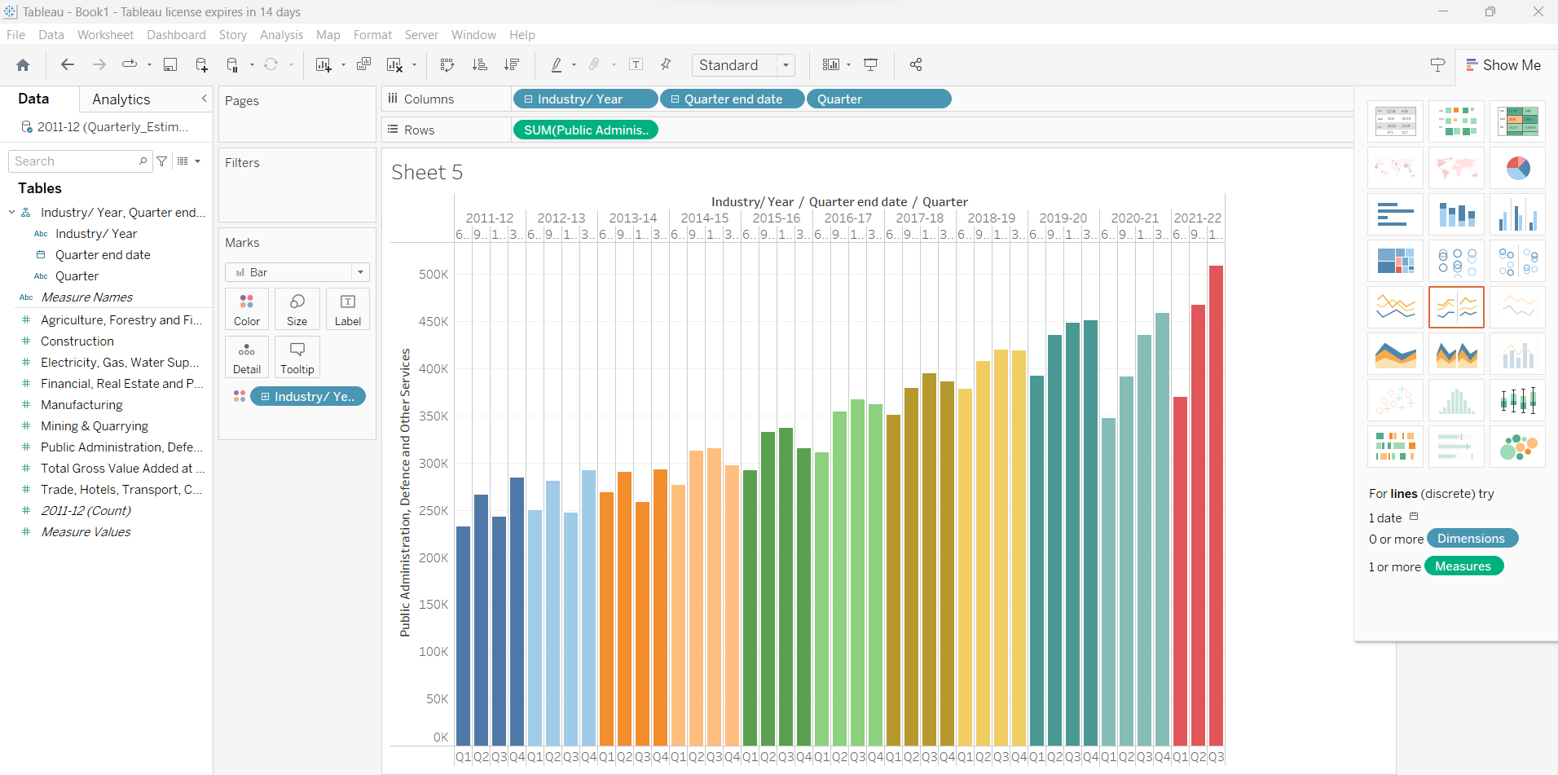

4.Plot multilevel bar chart for “manufacturing”, “construction”, “mining & quarrying”, and use highlighted features on “quarter” and “industry/year”.

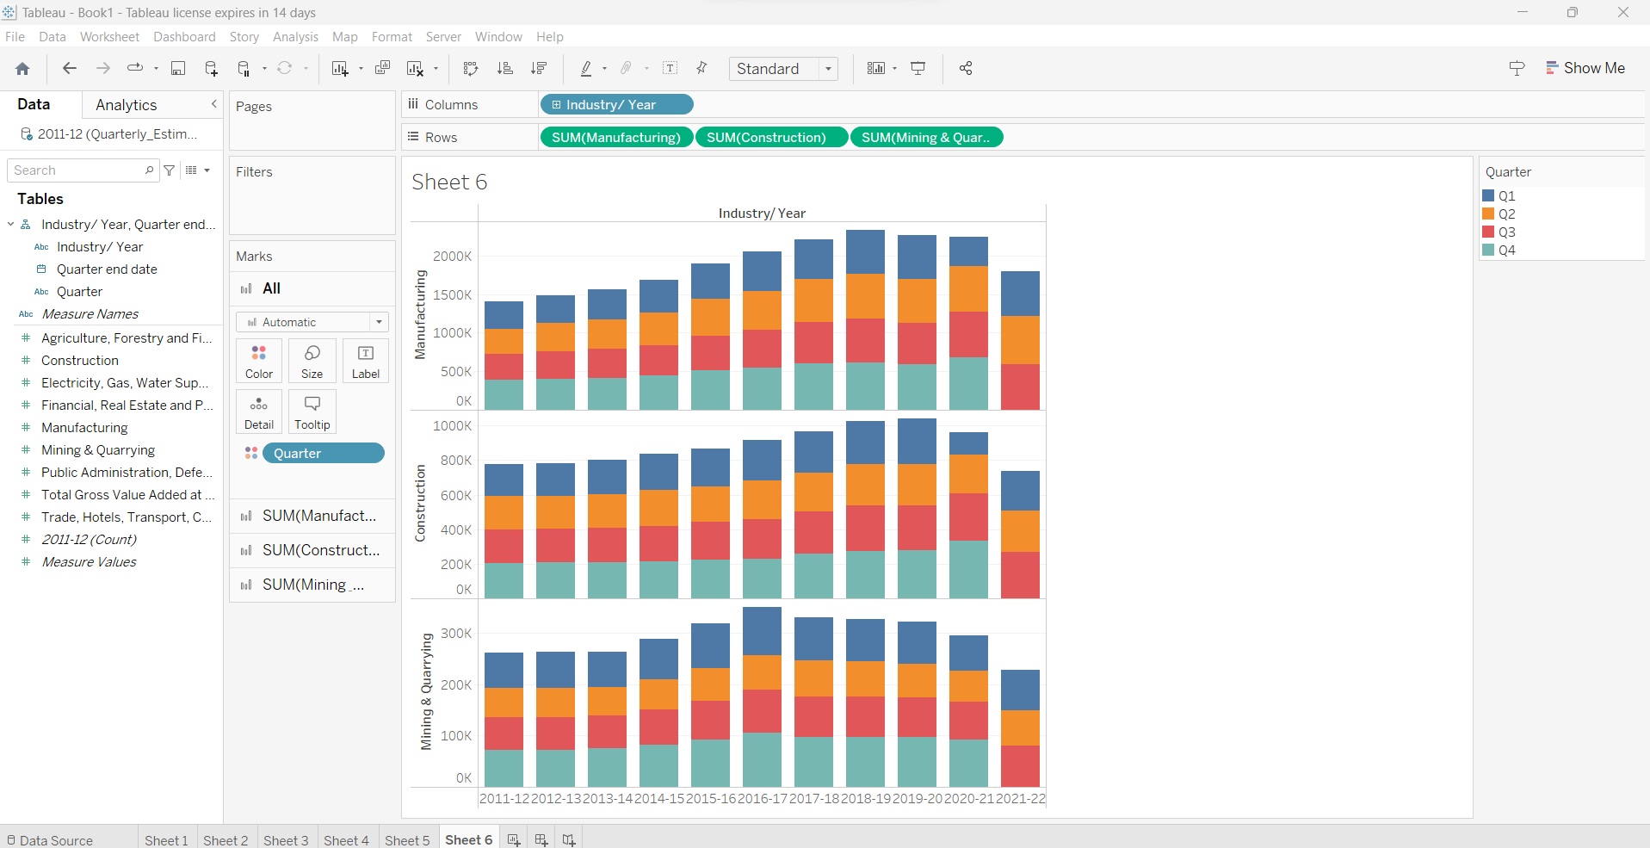

5.Find out in which year mining and quarrying contributed highest to GDP (Do sorting to find the answer visually).

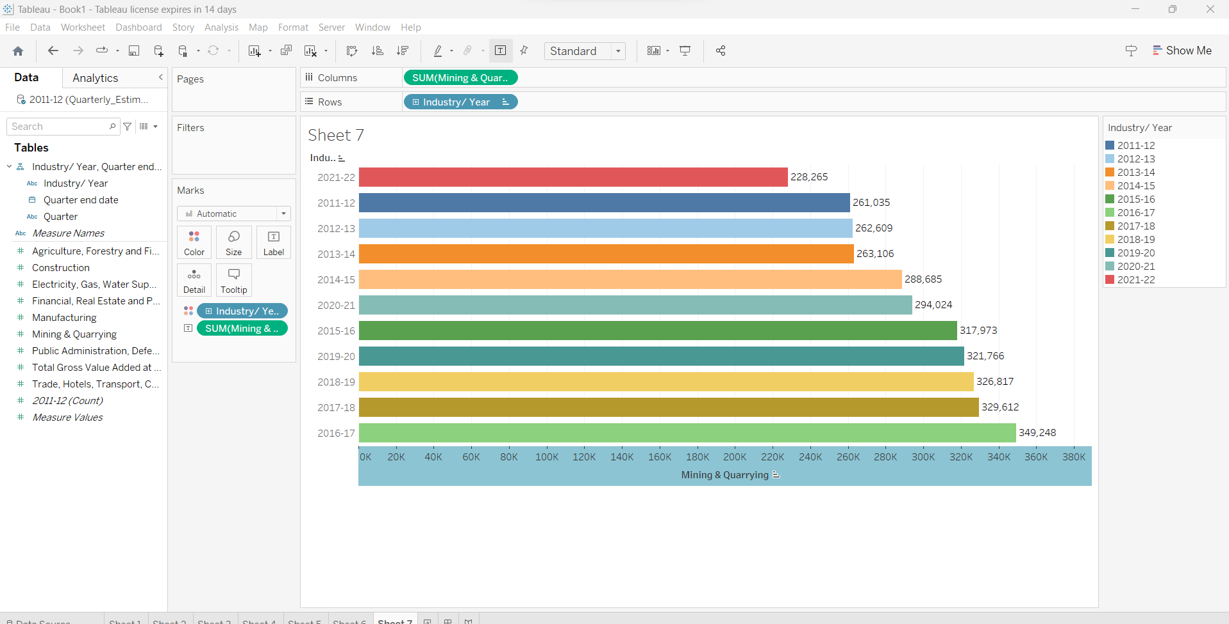

6.Create two groups of the last decade in a 5-year gap on “industry/year” and compare construction activity, (leave 2021-22 out of this because it is not part of the last decade).

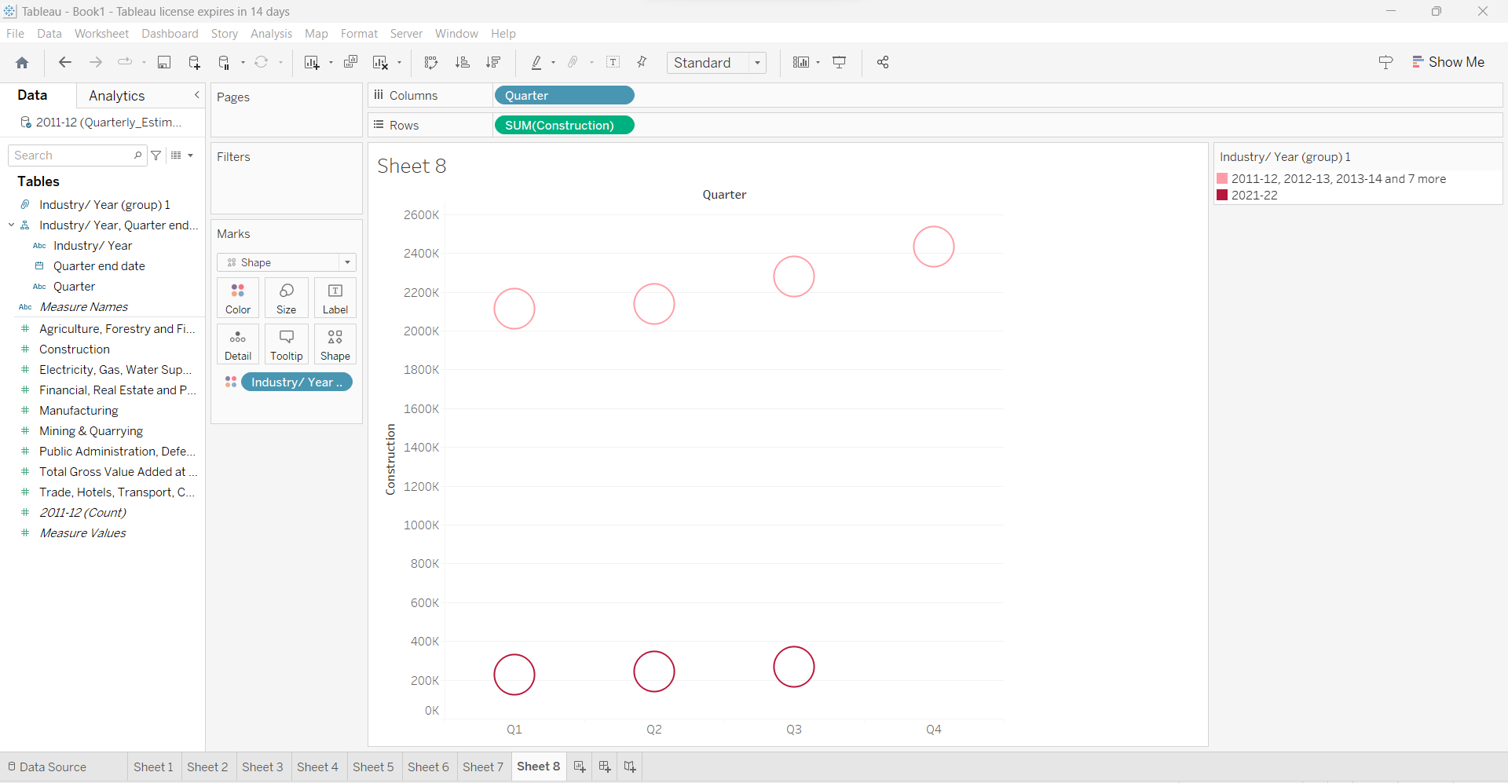

7.Use the filter on quarter and select only q1 and q2 data only then plot horizontal barchart for “Public Administration, Defence, and Other Services” by different color.

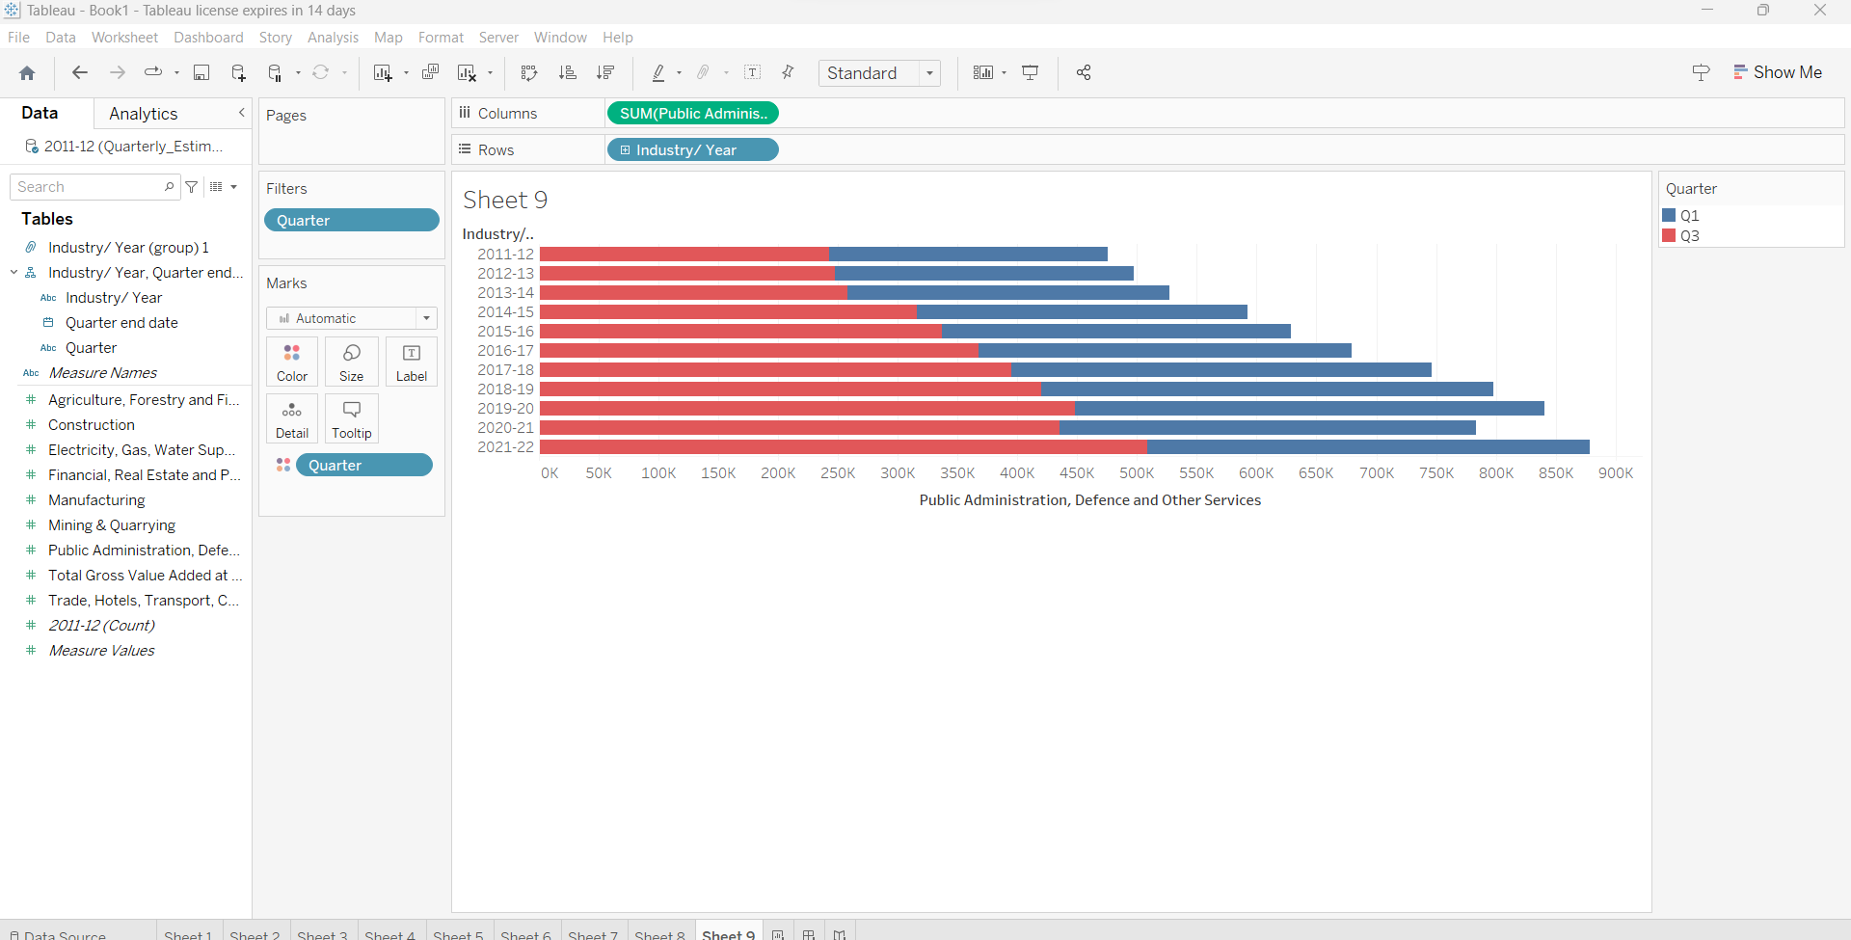

8.Create a set of Q1 as per their end date on the”quarter-end date”(select all data fromJune month) and compare“electricity gas, water supply and other utility” and visualized using a barchart, and give color to newly created set.

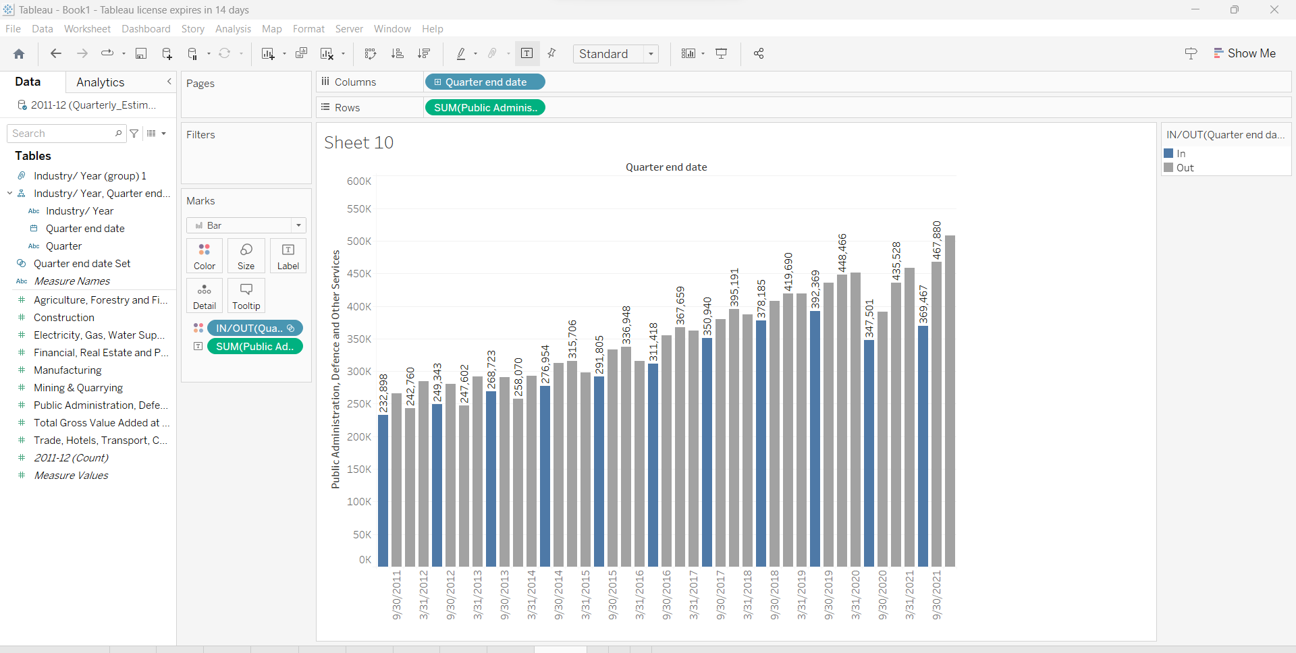

**Problem Statement 3 :**

Use the given dataset Marksheet.xlsx and load it into a tableau workbook.The following are the tasks that are to be taken into consideration while constructing graphs and charts in the worksheets.

**Dataset Description:**

The dataset contains data of the 12th std commerce stream where it has 5 subjects Accountancy , English, Maths, Economics, and BusinessStudies. And their marks are out of 100.Ithas 120 students total and is divided into 4 divisions A, B, C,and D equally.

1. Load the given datasets into a tableau workbook.

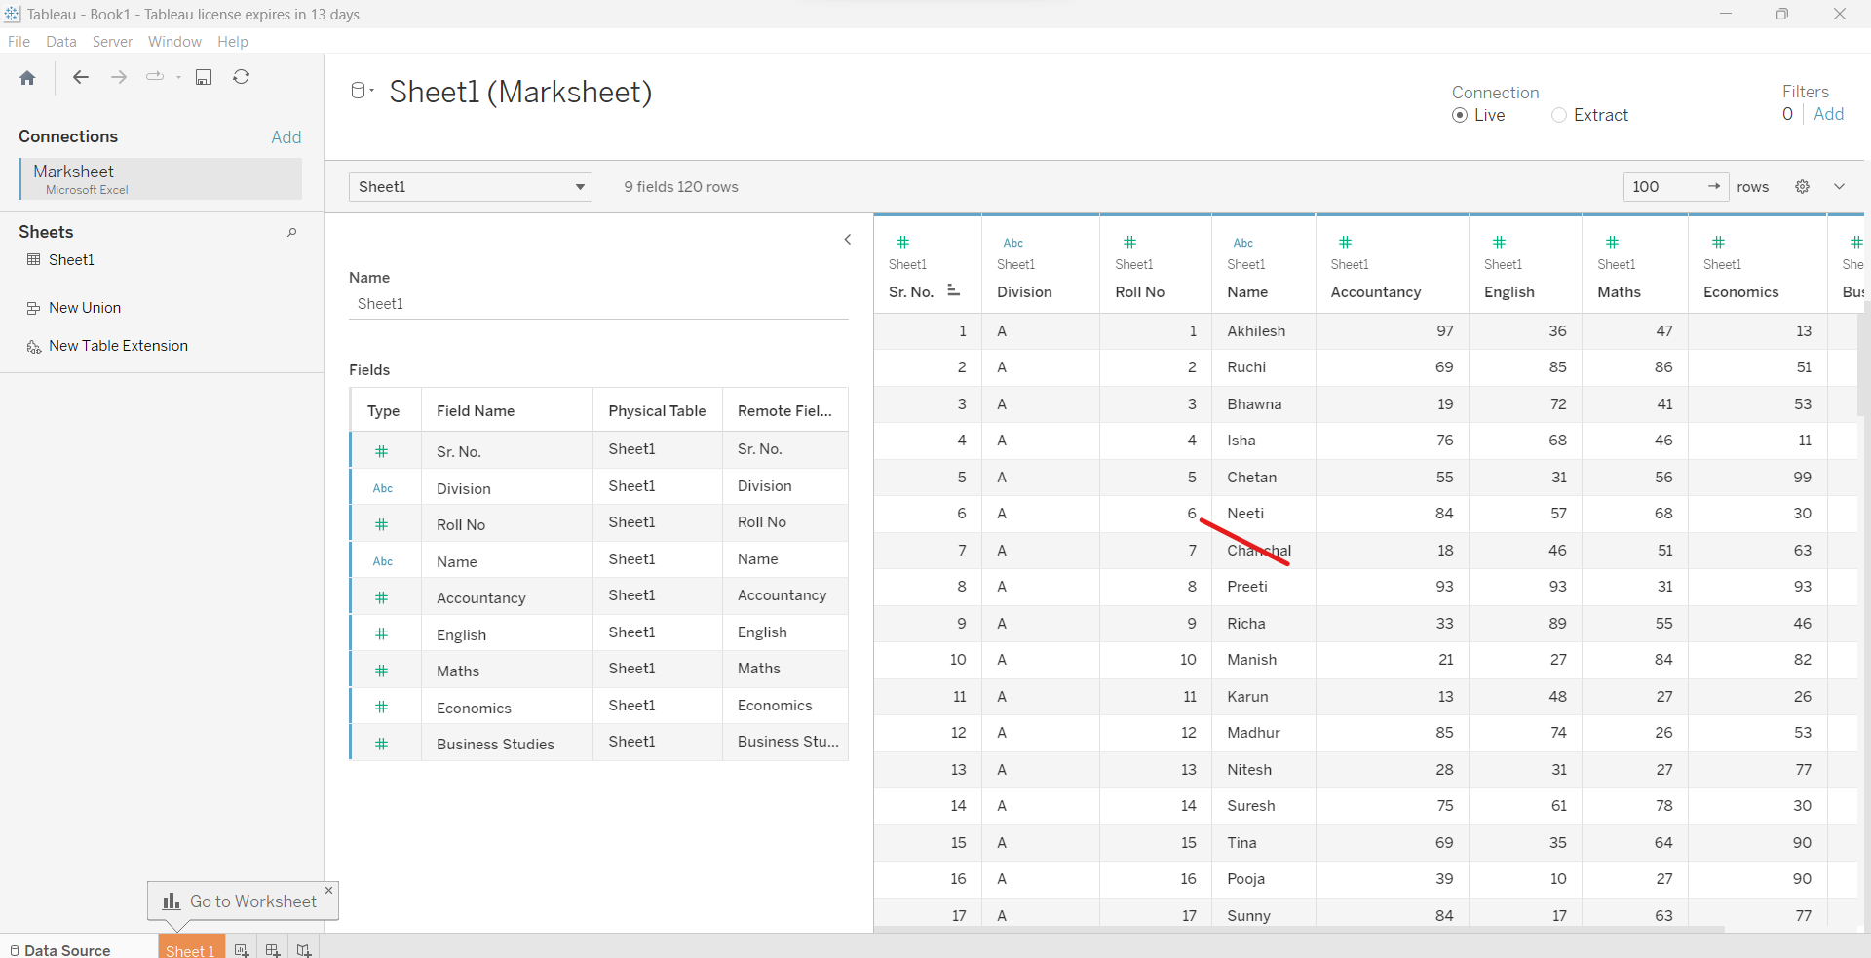

2.Create new calculated fields as “total” and add total of all subjects.

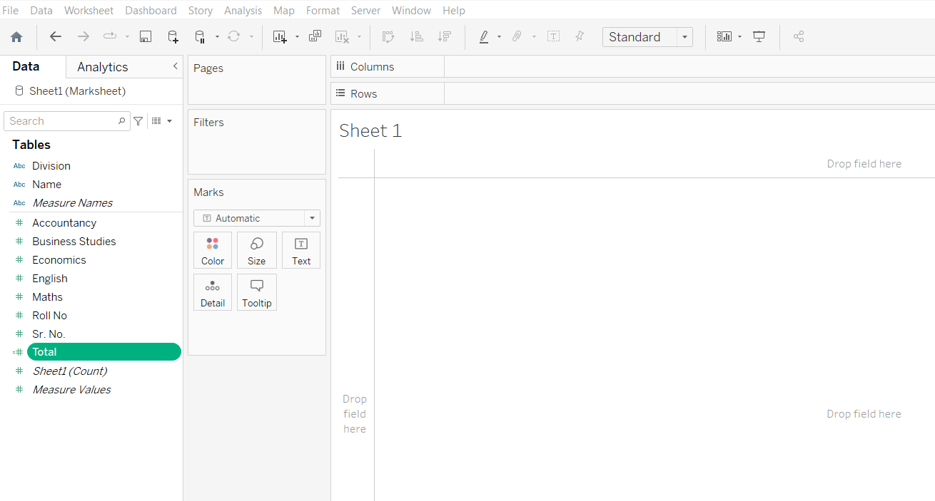

3.Create new calculated fields as “percentage” and find the student's percentage in the exam with help of “total”.

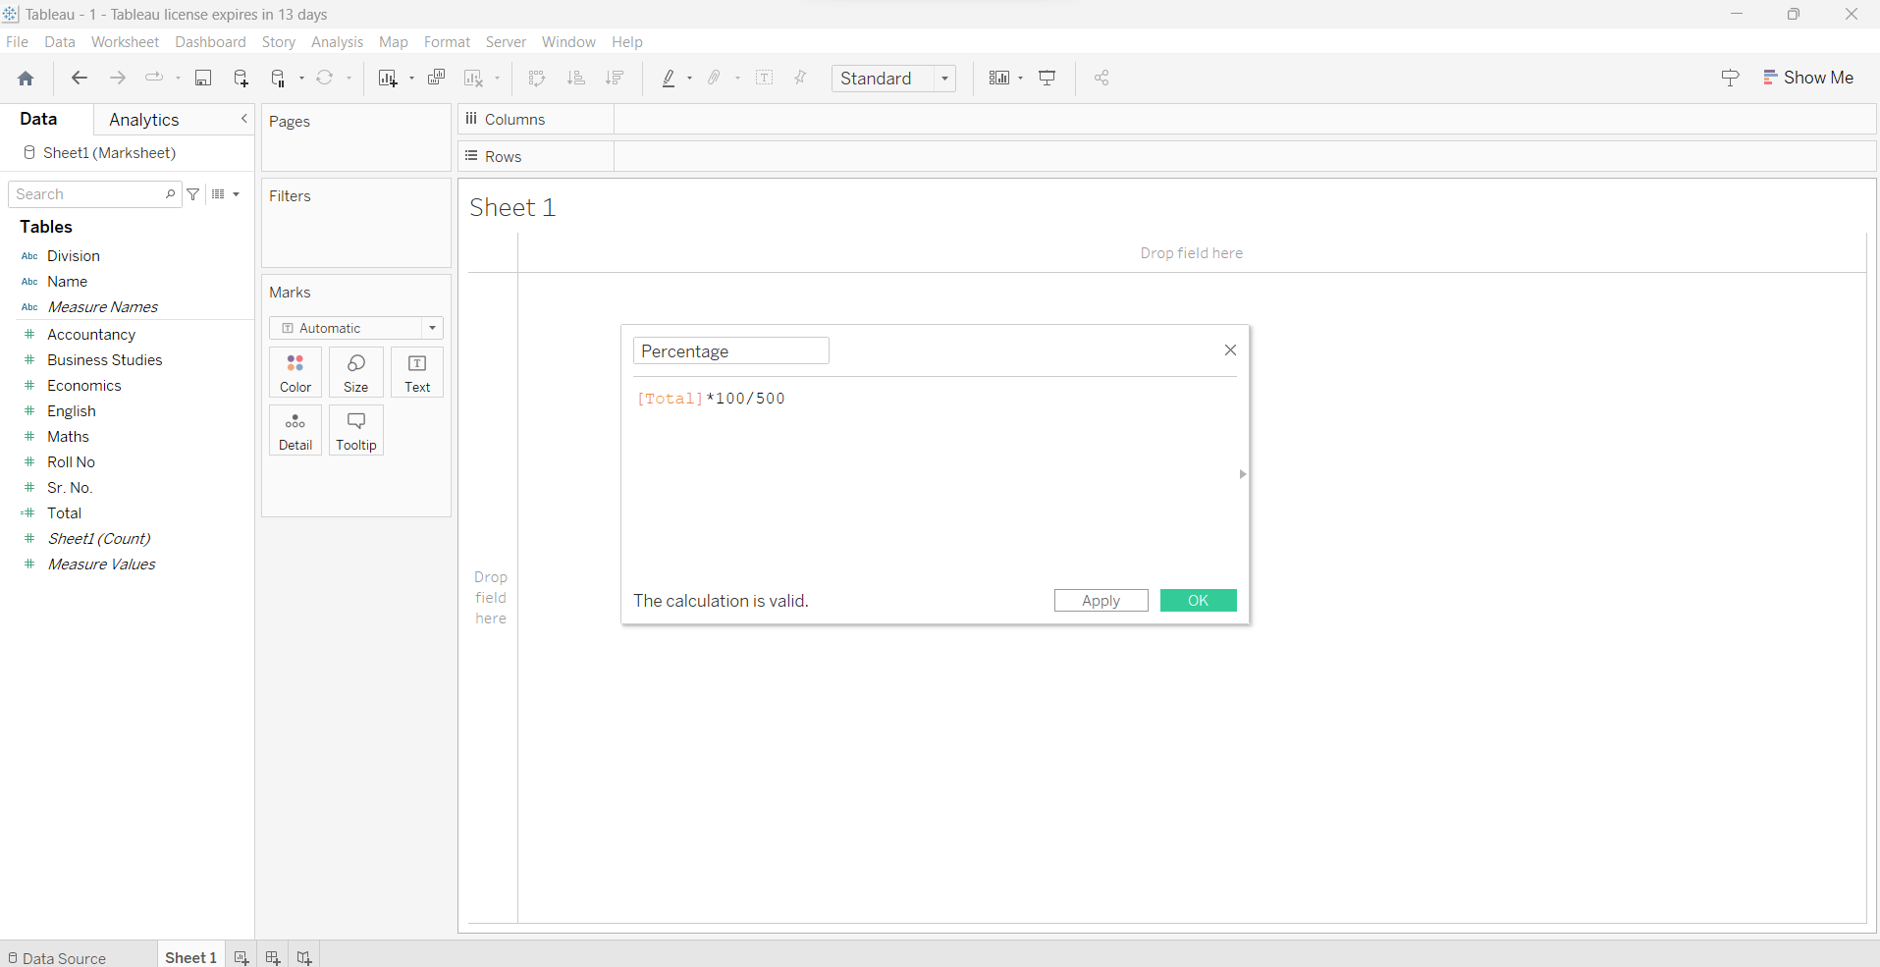

4.Create new calculated fields as “grade” and give them labels as if the percentage is < 40 then “F”, if < 50 then “D”, if < 60 then” C”, if< 70 then “B”, if < 80 then “A”, if <90 then”A+”, if >= 90 then “0”.

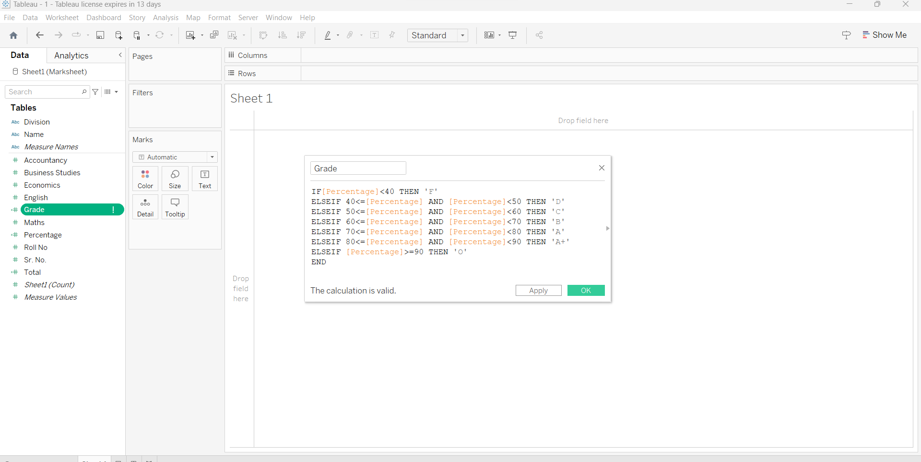

5.Create new calculated fields as “result” and give a pass if the student passed in every subject,” ER” if the student just failed in a single subject, and “failed” if they failed in more than one subject.

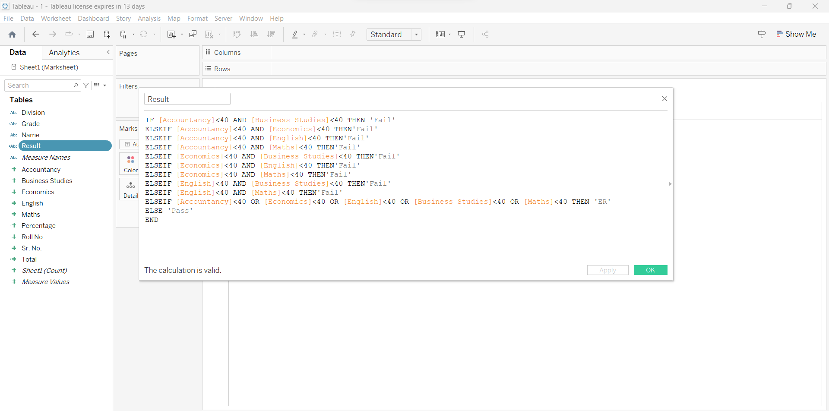

6.Use a packed bubble graph and figure out how many students are passed/fail or got ER.

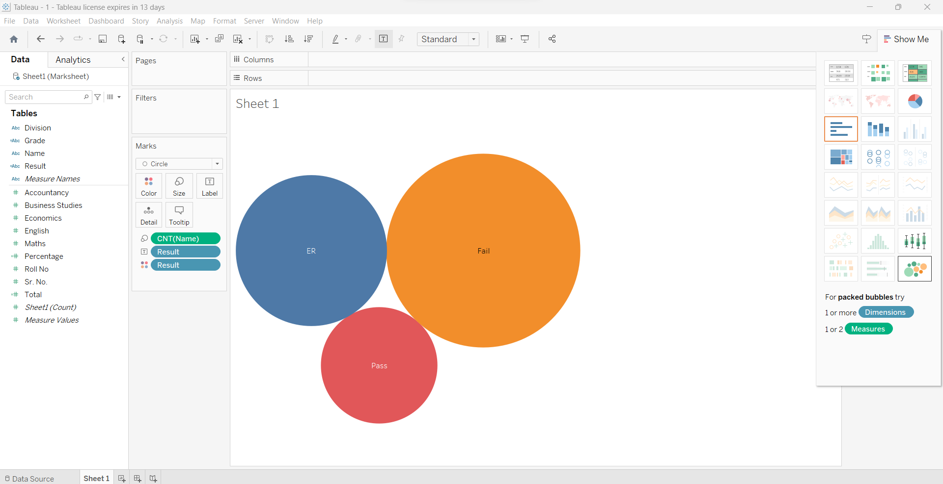

7.Use the vertical bar plot to distinguish students by their grades in each division.

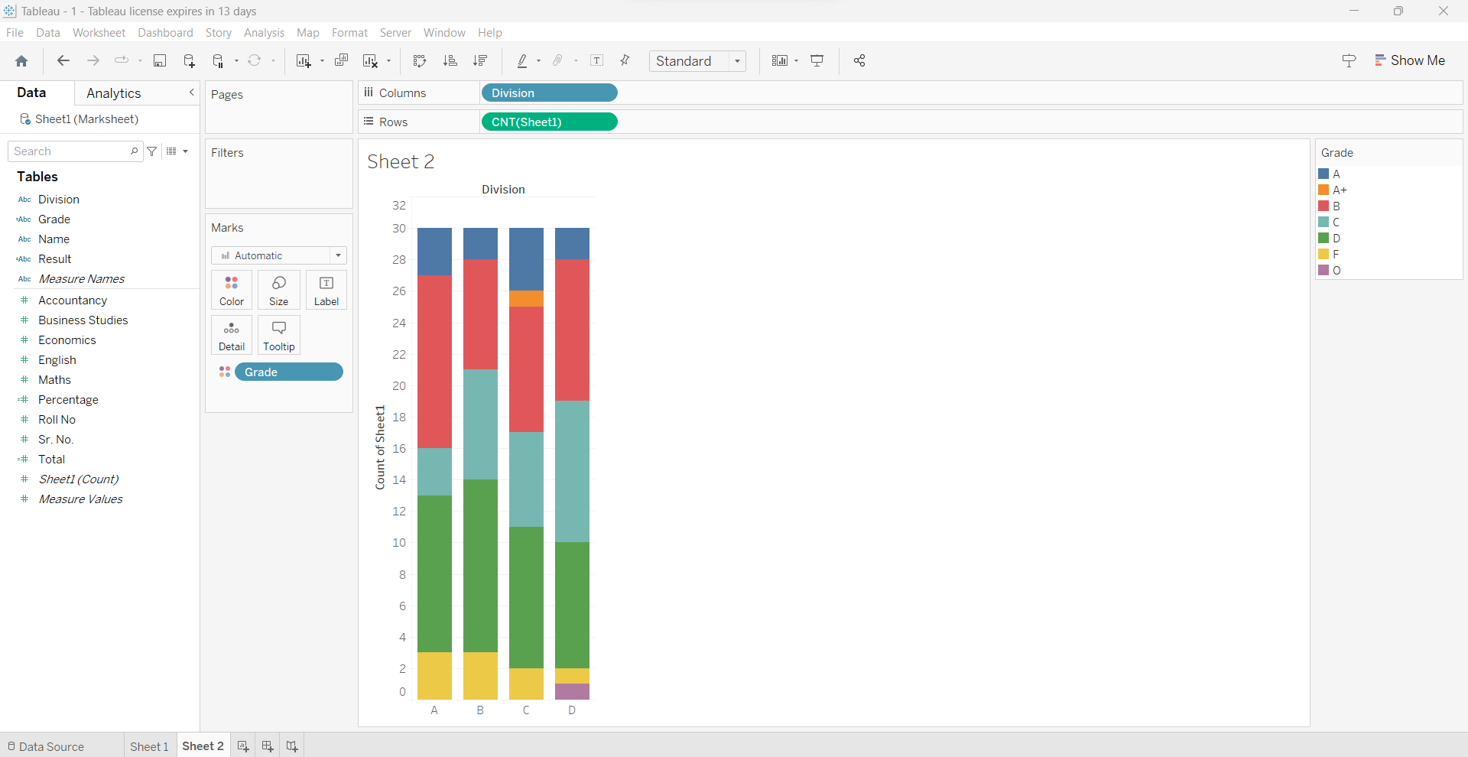

8.Find out the top 5 students from each division.

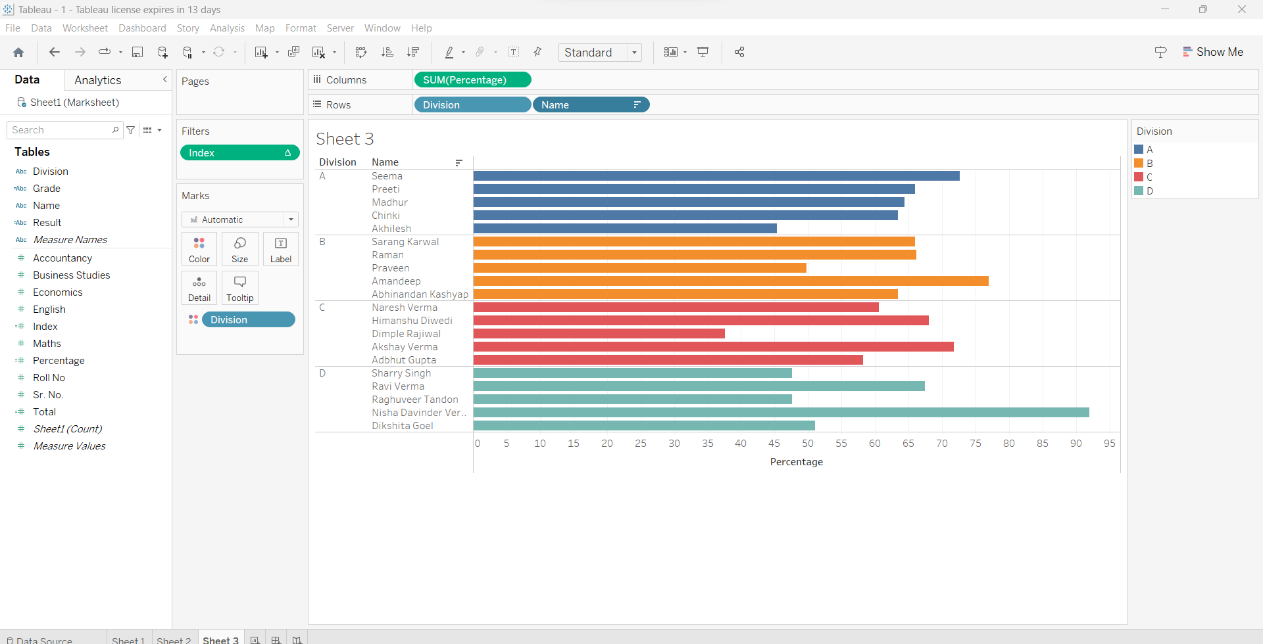

9.Filter out data where students got more than 60% and less than 80% as result and sort them in descending order.

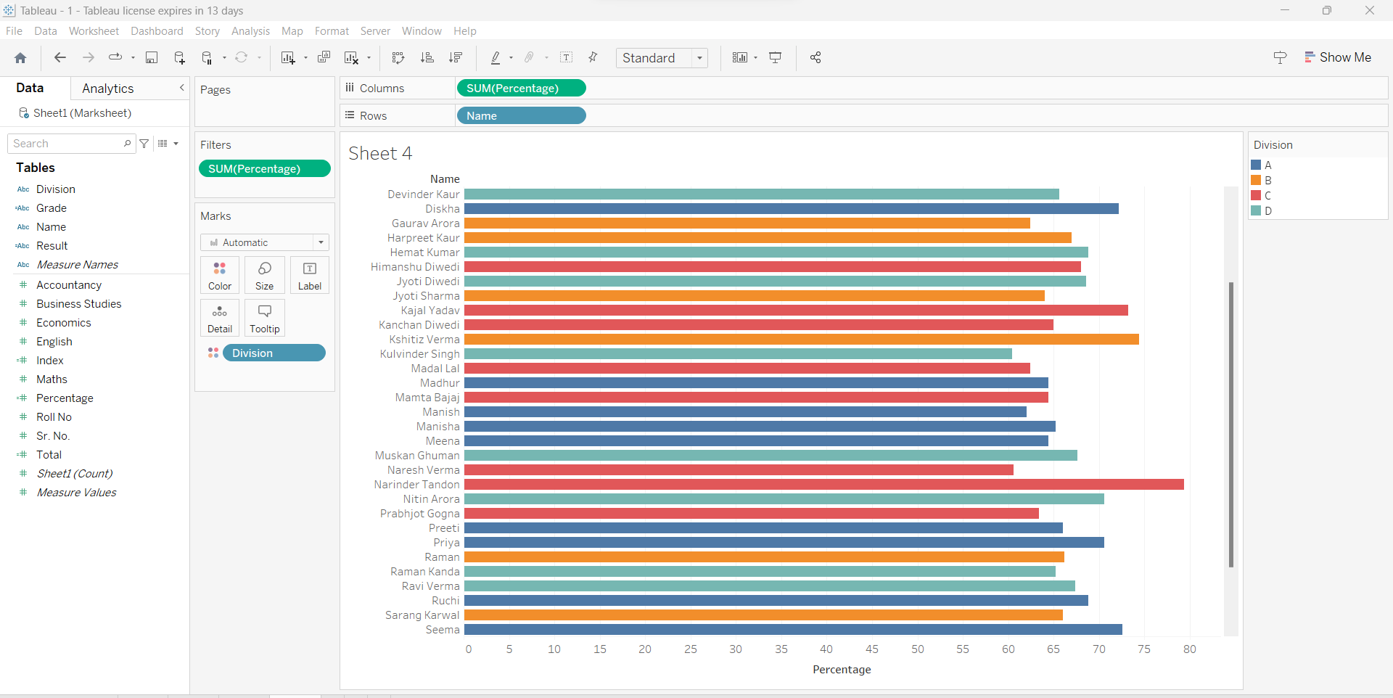

**Problem Statement 4:**

Use the given dataset UK BANK DATA.csv and load it into a tableau workbook. The following are the tasks that are to be taken into consideration while constructing graphs and charts in the worksheets.

1.Create a Map chart showing the number of transactions processed in each region.

Hints:

* Right-click on the Region field. Go to the Geographic role within that select“State/Province”.
* In Edit locations select the Country/Region menuang change the Country to the UnitedKingdom.

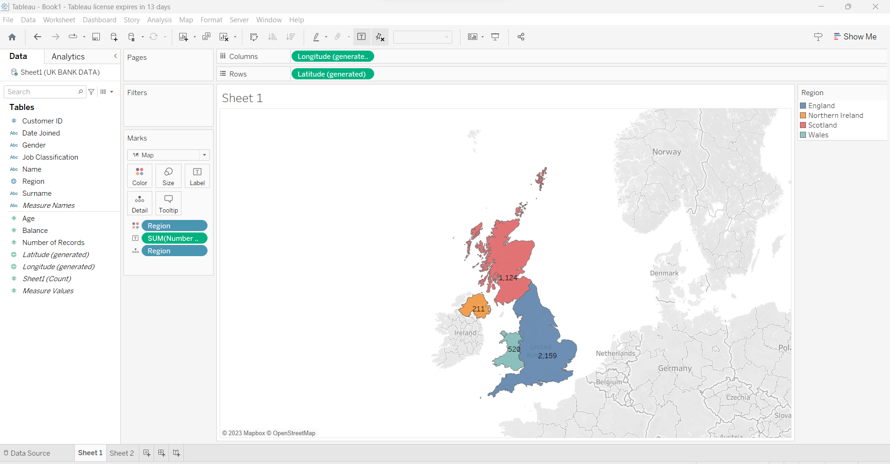

2.Create a Pie chart displaying the percentage of each transaction processed between genders.

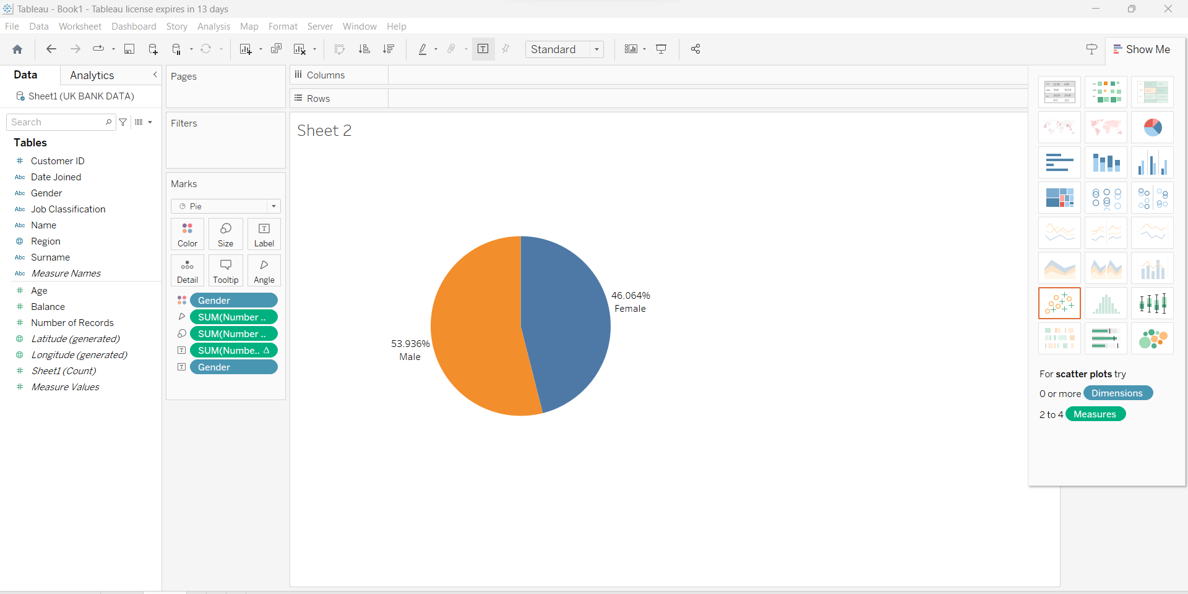

3. Create a Histogram displaying the distribution of age and transactions processed.

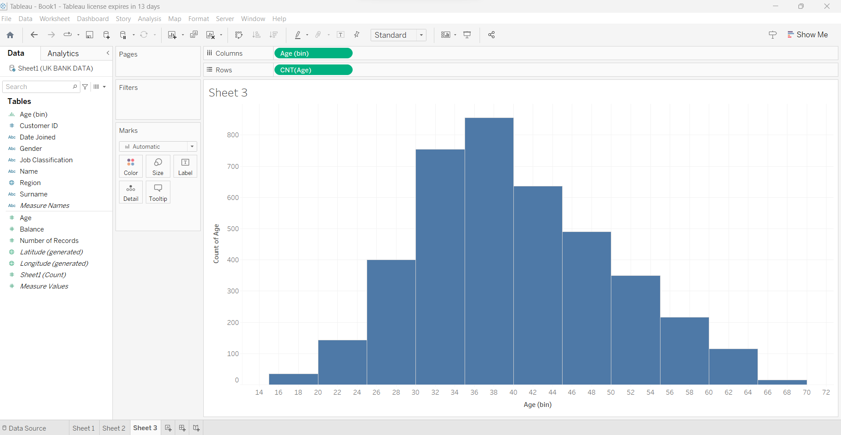

4.Create a Histogram displaying the distribution of balance and transactions processed.

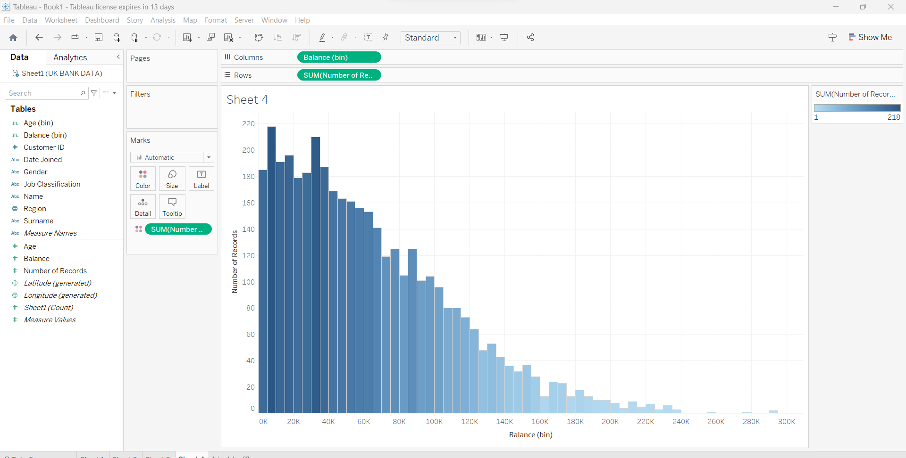

5.Create a Tree-map displaying the number of transactions processed within the classification of each job.

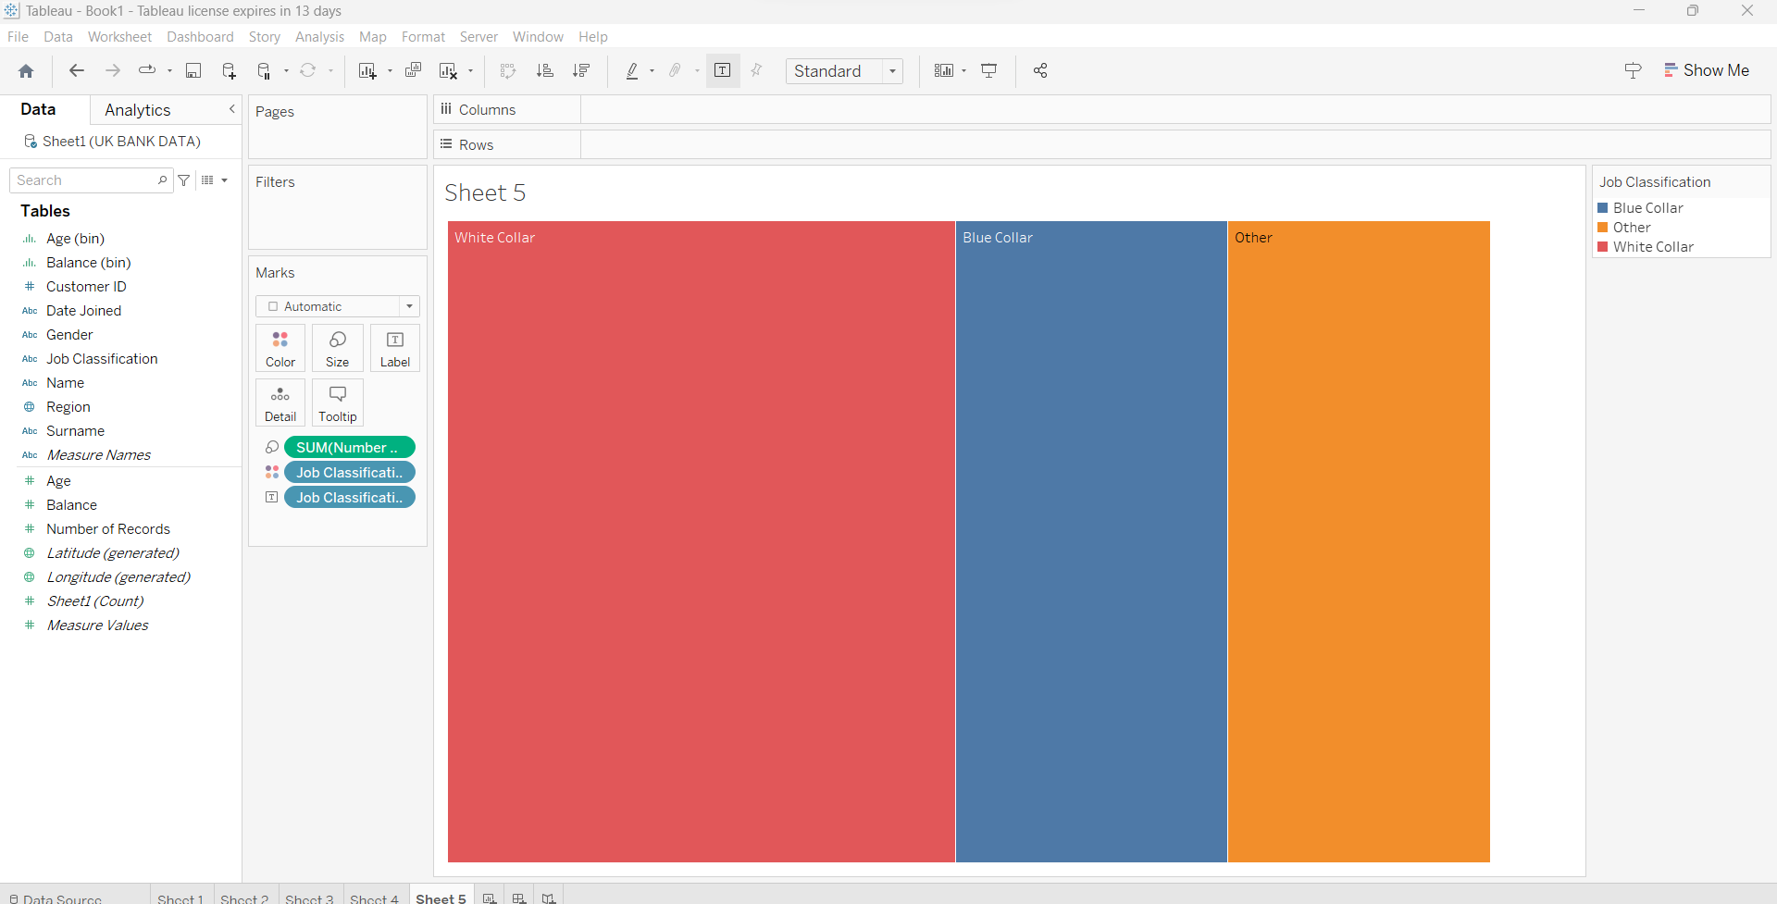

6. Create a Dashboard using all the charts. Make use of ActionFilters as it will further improve the analyzing experience for the management.

